Psychological Wellbeing at Work:
A Whitepaper for Post-Pandemic Organizations

Raechel Pefanis, MSW, RSW
Red Maple Professional Coaching Services

Introduction

If one were to question whether a mental health epidemic was at all a problem before the worldwide pandemic, one will certainly not question this afterwards. For roughly eighteen month beginning January, 2020, COVID-19 gripped hold of our planet, and squeezed it tight. Every system we knew, from small family units, to the largest of corporations, was pushed backwards into a state of destabilization and uncertainty. People, and the organizations they run, were forced deep into change and uncertainty that felt foreign to many.

We have spent a year in economic freefall. We have watched as worsening mental health among the general population took hold of our families, friends and co-workers. The disparities among people during the pandemic led, in part, to a new activism around diversity, equity, inclusion and belonging, including diversity in the form of a growing number of millennials marching into the workplace, millennials that were temporarily set back temporarily during the pandemic, but who desperately want opportunity and professional growth. All of these things have become individual arrows, pointing to a reality that every organization must see with wide, clear eyes: the reality that wellbeing -attentiveness, psychological safety, and coaching at work- is now a leadership mantle that must be taken up. We will need to institutionalize the wellbeing of the worker in ways that we have not in the past.

In a few short months when the world begins its’ reopening, post-pandemic workplaces will awaken to a mandate to prioritize wellbeing at work in every facet, from mental health response initiatives, to culture, leader and strategy challenges that must be faced. We have been challenged by plenty of hardship in 2020, but hardship, as we know, is also the birthplace of the new, and the improved. The dawn after the pandemic will put organizations right at the edge of a transformational opportunity, one in which to evolve, improve, and become leaders in their industries.

Dame Manouchehr Shafik points out that in the past, work was about muscle. Up to an including the pandemic, work was about brains. But the workplace of the future, she says, will be about heart. The opportunity to re-calibrate organizational life has presented itself. There is a chance to reset the habits, values and initiatives that make up our organizations, and to re-establish them as places of deep psychological health, building up layers of dignity, community, purpose and meaning within organizations as we all heal from what we have experienced. Those that don’t will quickly become irrelevant. Those workplaces that do so will find that they are catapulted forward as leaders in their industries, leveraging the financial rewards that come from this vitality.

The Economic Burden of Mental Illness

The Centre for Addiction and Mental Health in Toronto, Canada reports that as recently as 2011, the overall economic burden of mental illness in Canada is estimated to cost $51 billion per year. This number is equivalent, roughly, to 3% of Canada’s overall GDP. In the United States, The American Psychological Association estimates that more than $500 billion is siphoned off from the U.S. economy because of workplace stress, and 550 million workdays are lost each year due to stress on the job.
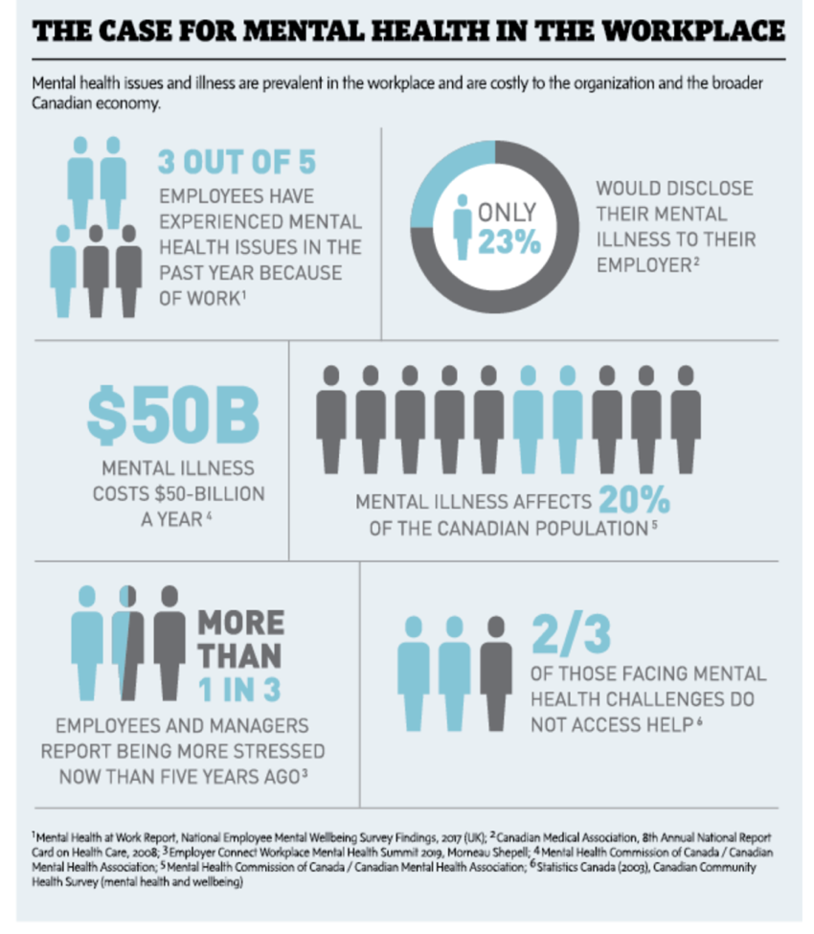
In 2020, the economic burden of mental illness became much further compounded by an “echo pandemic” of mental health problems. Between 2021-2025, 11 million more Canadians are expected to experience “high levels of stress in family and work settings,” and close to 2 million will experience “traumatic stress” as a result of the impact of COVID-19. One study, conducted by Deloitte, estimated that 10.7 million Canadians will visit a doctor for mental health issues during and after the pandemic, representing a massive increase over pre-pandemic levels of between 54% and 163%. To say that differently, first time mental health visits to family doctors will increase by a possible 163% because of the pandemic. To make things worse, this number only represents those who will seek treatment. It is to say nothing of those who will not opt to visit their doctor, despite their symptoms, particularly for women and other marginalized populations. Mental illness was a burgeoning problem before the pandemic, and COVID-19 compounded it. Within mental health, it is generally understood that “stress” is the great exacerbator of mental decline, and unfortunately, we are crumbling beneath it.
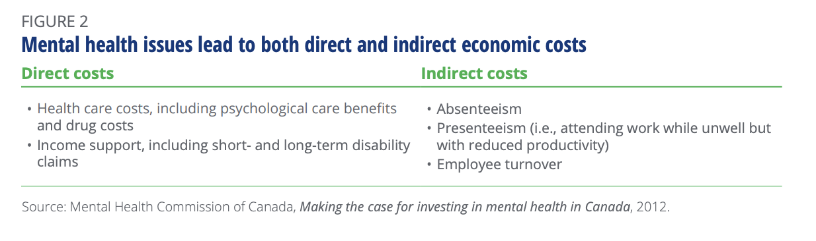
By the age of 40, 1 in 2 Canadians will have / have had a mental illness.
The Relationship Between Mental Health and Stress

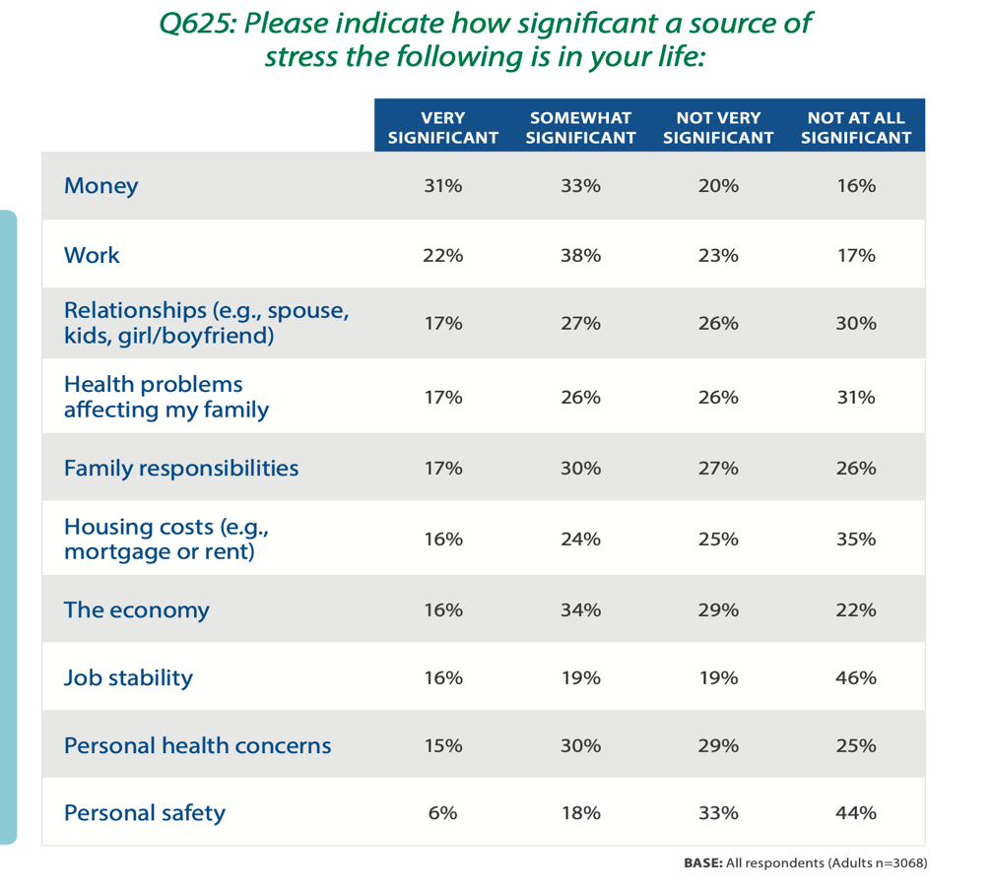
What is the source of the stress and mental health challenges we are seeing? Even before the pandemic, was this reality due to something being fundamentally “wrong” with the population? Was it because of a sudden collective change in brain chemistry? Is it that doctors diagnose it too quickly? Too little leg room on planes? Delinquent children? Aging parents? Where, exactly has this deterioration come from? What stress did the pandemic compound, exactly?

At first glance, many will assume that the emotional wellbeing of workers is utterly divorced and irrelevant from the business of the workplace, and that the two are not relevant, much less correlated. However, we must think again. Stress in America regularly looks for these answers, and they have demonstrated that when polled in recent surveys, people cite that the top source of their decline was their workplace, second only to stress about money. In fact, the American Psychological Association estimates that 60-80% of workplace absenteeism is directly attributed to stress at work. If ever there was a place to apply effort and stem the tide of mental illness, it is the workplace. The need for strong responses to the mental health epidemic is perhaps never more clear than in the individual impacts created from one case to the next, where the cost of a disability leave for a mental illness is about double the cost of a leave due to a physical illness. The mental health of employees plays a significant role in job performance and productivity, engagement with one’s work and colleagues, and ultimately, an employer’s bottom line. It has never been more clear that stress at work must be addressed in meaningful ways.

In 2020, major depression alone became the leading cause of disability in the workplace, as reported by the World Health Organization.

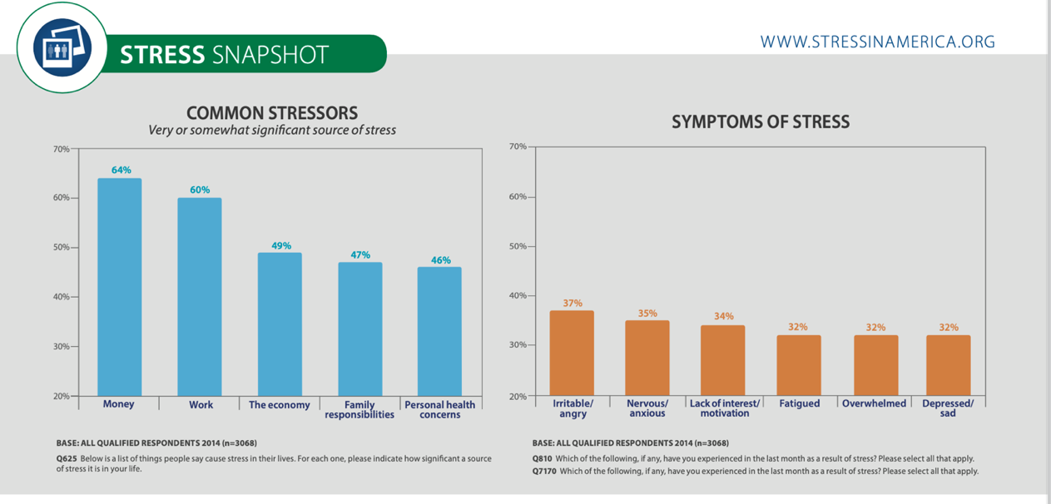
Workplace stress has been linked to health problems ranging from metabolic syndrome to cardiovascular disease and mortality. This includes health care costs, lost productivity, and reductions in health-related quality of life. More specific to the workplace, mental illness is the leading cause of disability by far, costing employers more than $6 billion in lost productivity and accounting for 70% of all workplace disability costs. There is no getting around the fact that stress at work is at the very least contributing to, if not causing, our collective decline.

Mental illness is real, and it is about to be very expensive. But, let’s pause: what do we even mean by “mental illness?” How is it different to terms such as “stress” or “pressure,” and what is the relationship between these things? Discussion typically revolves around the economic impact of known incidence of mental illness, which is to say, the classically diagnosed, quantified and measurable number of affected workers. But, what about mental decline that is not known or measured? What is the economic burden of that? What happens to workers when stressors pile up, when quality of work declines, or when and output is stalled for one reason or another? What are the physical, emotional, or relational symptoms that come from a worker in decline?

In any given week, at least 500,000 employed Canadians are unable to work due to mental health problems

What do we mean by “mental health?” and “wellness?”

Public understanding of the term mental illness has, after many years of stigmatization, begun to enjoy some daylight. For decades, many associated this term with incorrect ideas of frenzied, crazy, or maniacal states of being. Compounding these persistently unhelpful ideas was the lack of a language set around mental illness. Consider the terms mental illness, mental injury, trauma, crazy, unstable, and disability. What do these terms reflect? How are they similar or different? Terminology about these things is difficult to understand, and even more difficult to communicate about. This is a reality that reflects the generally poor understanding of how to speak plainly about these states of being, and, more importantly, the impacts that they create for both the individual and the organization.

Today, we are making good strides to create a more educated public about mental illness, thanks to public health campaigns that bust these types of myths. That said, there is much more to be done to create understanding, not just about mental illness, but also mental wellness, because diagnosed mental illnesses are, in fact, the backend of a wellness continuum that has gone wrong.

These confounding concepts are perhaps best understood on a continuum of mental wellness, from -3 on the left side and +3 on the right side:

|------------------------------------------------------------|--------------------------------------------------------|

-3 -2 -1 0 +1 +2 +3

The Continuum of Mental Wellness

On this scale, the far-left number of -3 represents the most compromised states of mental wellness, states that comprise high acuity of symptoms including severe and persistent mental illnesses that require in-patient hospitalization and treatment. Presenting cases at this stage tend to be problems like paranoid schizophrenia, treatment resistant depression, suicidality, or severe substance misuse. These are problems that affect people across demographics, including more white-collar professionals than most would predict.

Moving up the continuum, -2 might refer to stable illnesses, such as trauma, depression or anxiety that can be treated outside of a hospital. -2 might also refer to problems such as eating or habit disorders, obsessions and compulsions, or panic disorders that, while not at all an example of a high quality of life, can be met with community-based services.

In the case of -1, a person will be living with diagnosed mental health disorders that are symptomatic, but where the person is functioning at work and at home. This might include depression with some active symptoms, or anxiety that is bothersome, but where these things are not rendering the person disabled. .
The “0” on the scale represents a “neutral” point on the continuum. In this case, the person is considered to be asymptomatic. Any diagnosed mental illnesses or injuries are managed through a mix of medications, psychotherapy and lifestyle treatments, and the person is free of worsening conditions. But neutral, as we know, is not “thriving.”

At the “+1” stage, quality of life begins to climb. We begin to look at how a person is now starting to do things they like and are engaged in, including on the job. They may begin to find their signature strengths and use them. They are likely to enjoy friendships and enjoyable activities.

At +2, we see a person not only expressing their best talents and signature strengths, we also see intentional decision making to improve wellbeing, such as getting toxic people and situations out of their lives, or making deeply value-centred decisions. These people are clear-eyed on their beliefs, and live in a state of congruence to them.

Finally, at +3, we find that not only are these thriving people leading a life of deep intention and clarity, they have also begun to turn their attentions to the development of other people and projects that require their leadership and guidance. Many think the +2 / +3 people of the world to be “high performing” individuals, a term that is probably very apt.

There are many realities about this continuum that become important to workplaces because stress, as we have learned, is derived from the workplace. Organizational life has a deep impact on whether people are sick, or whether they are thriving. High performers do not stick around in workplaces that look -culturally- more like a -2 or -3. A workplace whose systems erode the wellbeing of their people, via drip and drab or via seismic events, should not become dumbfounded when productivity and ROI begin to drop. We must remember that “work stress” drives down vitality and humanity, a reality that the pandemic has worsened. We simply cannot afford to be obtuse about the deep impacts that work has on quality of living, and the ethical imperative that post-COVID workplaces will have on getting this very, very right. But just in case this were in doubt, let’s make one last consideration before we arrive at our paths forward.

How does work intersect with mental health and wellness?

Since the 1990s, Gallup has been measuring international employee satisfaction through a survey it has been honing over the years. In total it has polled 25 million employees in 189 different countries, and it has made some interesting findings. The latest version, released in 2013, gathered information from 230,000 full-time and part-time workers in 142 countries, where the following was found.

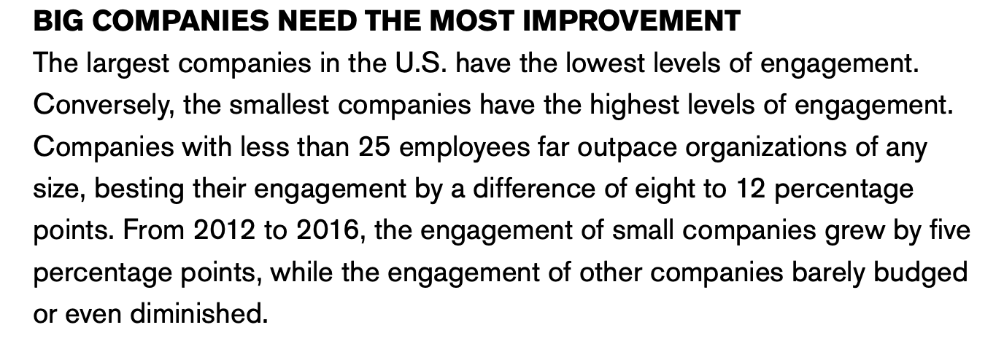
Only 13% of workers feel “engaged” by their jobs, meaning they feel a sense of passion for their work, a deep connection to their employer, and where they spend their days driving moving their company forward in interesting ways. Source: Gallup: State of the American Workplace

63%, are “not engaged,” meaning they are unhappy but not drastically so. In short, they’re checked out. They sleepwalk through their days, putting little energy into their work.
A full 24% are what Gallup calls “actively disengaged,” generally referring to the “I hate my job” sentiment. Many of these workers will even go on to act out and undermine what their coworkers accomplish, or even sabotage the organization.

Add the last two categories and you get 87% of workers worldwide who, as Gallup puts it, “are emotionally disconnected from their workplaces and less likely to be productive.” In other words, work is more often a source of frustration than one of fulfillment for nearly 90% of the world’s workers.

47% of working Canadians consider their work to be the most stressful part of daily life.

Psychological Health and Safety at the Organizational Level

To stem the tide of mental health, including the decline that begins long before formal diagnosis, innovative solutions will need to be found. These solutions are generally categorized into two streams: individual solutions, and organizational solutions. Individual solutions refer to those mechanisms that react to mental illnesses when they present, such as third-party mental health benefit, or mechanisms for managing disability and return to work plans. Many of these solutions are now commonplace and, where they are not, they are quickly becoming so. What is less clear are the organizational solutions that work to prevent against workplace stress in the first place, given the clear decline in wellbeing that it leads to. Today, workplaces must begin to seriously consider how to stem the tide of poor mental wellbeing, long before mental illnesses and injuries becomes diagnosable. While there are problems, there is also great potential for human thriving because of work. If most are disengaged or actively disengaged, then what would happen if most could be engaged? If organizational life was designed for deep purpose, meaning and connection, what would the state of our mental wellbeing look like? And, how would that wellbeing translate into economic output of organizations?

The key to preventing an erosion of wellbeing, at least insofar as workplaces are concerned, is the creation of a work culture that meets a high watermark: psychological health and safety, at all levels of the organizations. What does this heady term mean? It means that a workplace is run in such a way that “thriving” is made possible, for those that want it.

Psychological health and safety in the workplace: the prevention, promotion, and guidance to staged implementation of a workplace that promotes workers’ psychological wellbeing, and actively works to prevent harm to psychological health, including negligent, reckless, or intentional ways.

Worker wellbeing: a state of being in which an individual realizes his or her own abilities, can cope with stresses of life, can work productively and fruitfully, and is able to make a contribution to his or her community.

Psychological Health and Safety: How Does an Organization do it?

A walk down many “Main Streets” in Canada today will lead to an astute observation for those that look carefully: the growing presence of goods and services that meet the appetite for wellness. What used to be boutique clothiers, large banks or hardware stores are being replaced with nail and lash bars, cycle clubs, and specialty coffee bars. While religious spaces are emptying in droves, organic candle companies, aesthetics providers and community gardens are often high growth businesses in many communities. At the core of most communities is a wellness revolution.

Organizations that create psychological health and safety are those that create a scaffolding of effective ways in which the worker can experience regular surges of wellbeing. These organizations craft themselves such that people experience a bit of motivation here, a dose of positive interaction there. Generally, this is a customized set of structures, unique and contextualized to the industry, demographic, and social considerations of that unique workplace. Deloitte sets out three stages of initiatives that represent efforts a workplace can take, referring to these as early, developing and aspirational stages. These initiatives demonstrate what a full range of ways in which organizations can begin to do this critical work.

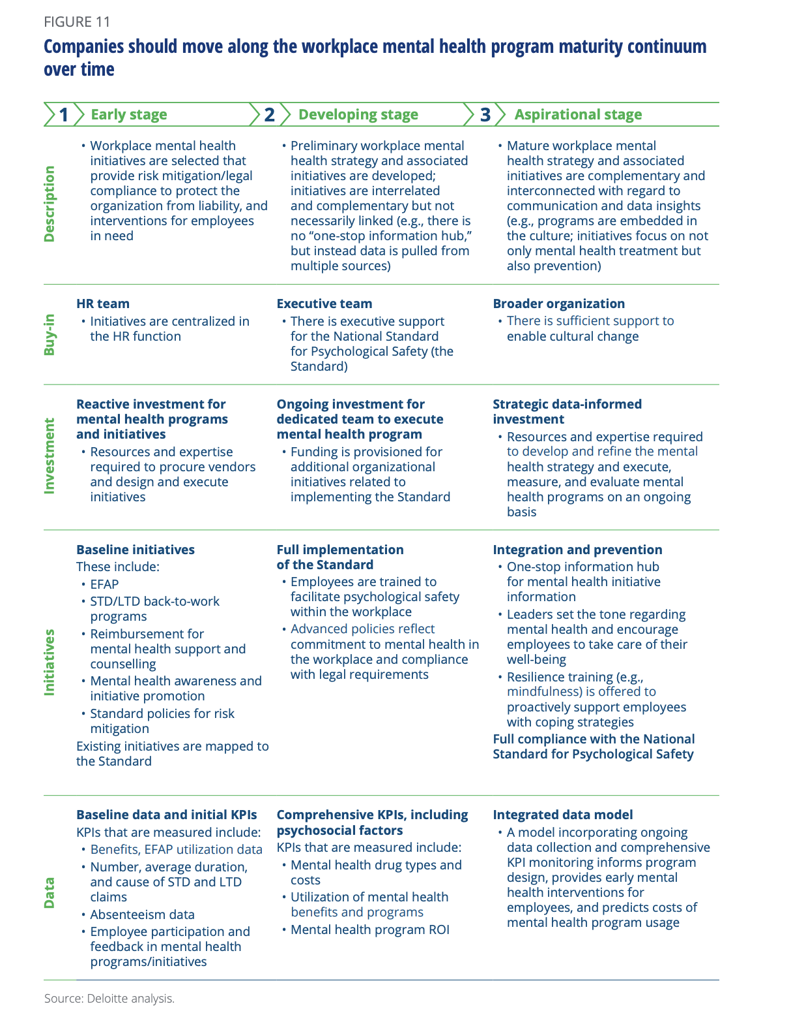

Congruent with the framework put forward by Deloitte, the Mental Health Commission of Canada has put forward a National Standard or Psychological Health and Safety in the Workplace that details how workplaces can begin to think innovatively and deeply about these issues at the organizational level. Perhaps most helpfully, Simon Fraser University, based on extensive research and review of empirical data from national and international best practices, has put forward thirteen psychosocial risk factors (PSRs) that have been identified as those most important to a workplace that promotes wellbeing. Since psychological health and safety is generally embedded in the way people interact with one another on a daily basis, and since it is part of the way working conditions and management practices are structured, it is helpful to become as concrete as possible, which these risk factors help us to do. Over time, these practices are like a north star for organizations, helping them to check the psychological health and safety of the workplace, and to ask what might be done to continually improve it, just as it would with financial or operational benchmarks. A summary of those thirteen risk factors is seen below.

Psychosocial Risk Factor | What is it? | What happens when it is lacking?
Psychological Support | Habits of work that take regular consideration of the psychological wellbeing of workers, and respond appropriately. | Absenteeism, withdrawal behaviour, strain and turnover. Physical symptoms such as headache or anxiety leading to loss of productivity, greater risk of accidents, incidents and injuries.
Organizational Culture | The degree to which a work environment is characterized by trust, honesty, and fairness, and the assumptions at play in the way people behave. | Unhealthy cultures –ones that are typified by distrust, dishonesty or unfairness- will lower worker wellbeing. A “profit at all costs” culture will create chronic urgency, leading to burnout.
Clear Leadership and Expectations | People know what they must do, and how to do it. Leaders are “transformational” agents who motivate workers in compelling ways, giving individual consideration to each person. | Top down, control-and-command leadership will create irritability, nervousness and malaise in workers. Health complaints will increase.
Civility and Respect | Organizations have created a positive atmosphere marked by high spirits and satisfaction that people enjoy coming to. | A workplace that lacks civility and respect can lead to emotional exhaustion amongst staff, greater conflicts, job withdrawal and exposure to threat of grievances and legal risks.
Psychological Competencies and Requirements | A good fit between employees' interpersonal and emotional competencies, their job skills and the position they hold. | Job strain, expressed as emotional distress, excessive dwelling on thoughts, defensiveness, energy depletion and lower mood levels. Job misfit is linked to fewer applicants in the recruitment and training process, lack of enjoyment and engagement, poor productivity, conflict, and greater voluntary turnover.
Growth and Development | A workplace where employees receive encouragement and support in the development of their interpersonal, emotional and job skills, including the promotional abilities that follow. | Employees who are not challenged by their work will grow bored, their well-being will suffer, and their performance will drop. When staff do not have opportunities to learn and improve their interpersonal and psychological skills, the result can be conflict, disengagement and distress.
Recognition and Reward | A workplace where there is appropriate acknowledgement and appreciation of employees' efforts in a fair and timely manner. | Lack of recognition and reward undermines employee confidence in their work and trust in the organization. Employees may feel demoralized or they may quit. An imbalance between effort and reward is a significant contributor to burnout and emotional distress leading to a range of psychological and physical disorders.
Involvement and Influence | A workplace where employees are included in discussions about how their work is done and how important decisions are made. | If employees do not believe they have a voice in the affairs of the organization, they tend to feel a sense of indifference or helplessness. Job alienation or non-involvement is associated with cynicism and distress, greater turnover, and burnout.
Workload Management | A workplace where tasks and responsibilities can be accomplished successfully within the time available. It is not only the amount of work that makes a difference but also the extent to which employees have the resources (time, equipment, support) to do the work well. | Excessive job demands reduce job satisfaction, while intellectual demands or decision-making increase job satisfaction. When there are high demands, employees that have high decision-making ability will generally thrive.
Engagement | Employees enjoy and feel connected to their work, feeling motivated to do their job well. Employee engagement can be physical, emotional or cognitive. | They demonstrate greater turnover, withhold effort from the job, and exhibit counterproductive behaviours more.
Balance | There is recognition of the need for balance between the demands of work, family and personal life. | undermined by accumulating home and job stress. This imbalance can lead to:  - constant tiredness  - bad temper  - inability to progress  - high job stress resulting in dissatisfaction with work and being absent either physically or mentally  These effects can then lead to additional stress-related illness, as well as higher cholesterol, depressive symptoms, and overall decreased health. The impact on the organization can include increased costs due to benefit payouts, absenteeism, disability, and turnover. Not all employees will have the same work-life balance issues. Age, cultural, gender, family and marital status, care-giver demands, socioeconomic status and many other factors affect an employee's work-life balance. Organizations will benefit from having flexible arrangements to address this issue.
Psychological Protection | Workplace psychological safety is demonstrated when employees feel able to put themselves on the line, ask questions, seek feedback, report mistakes and problems, or propose a new idea without fearing negative consequences to themselves, their job or their career. A psychologically safe and healthy workplace actively promotes emotional well-being among employees while taking all reasonable steps to minimize threats to employee mental health. | When employees are not psychologically safe, they experience demoralization, a sense of threat, disengagement, and strain. They perceive workplace conditions as ambiguous and unpredictable. This demoralization can, in turn, undermine shareholder, consumer, and public confidence in the organization.
Protection of Physical Safety | This factor includes the work environment itself. Steps can be taken by management to protect the physical safety of employees. Examples include policies, training, appropriate response to incidents or situations identified as risks, and a demonstrated concern for employees' physical safety. | Failure to protect physical safety results in workplaces that are likely to be more dangerous. Not only could employees be injured or develop illnesses, those who do not see their workplace as physically safe will feel less secure and less engaged.

The psychosocial risk factors are one way to talk about the importance of wellbeing at work. Many organizations will not turn their minds and organizations toward well run, psychologically healthy and safe places for ethical reasons, and so, for them, we must instead point to the economic gains that these efforts give us. Deloitte gives us one way to calculate what those gains might be, below.

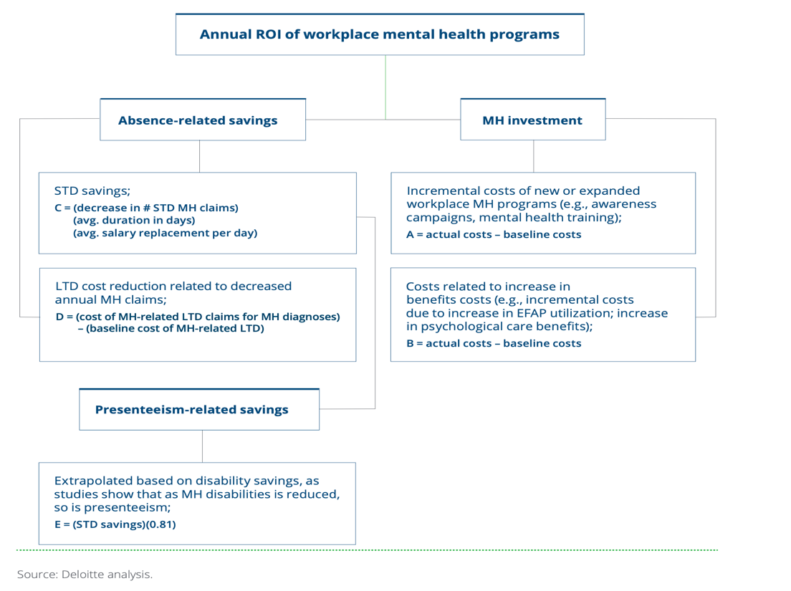

Conclusion

The economic burden of mental health, a problem in its’ own right, has been deeply compounded by the worldwide pandemic. Stress from work is the largest stressor there is in self-reports, second only to stress about money, and stress is the enemy of good wellbeing. The solution to this must include strong remedies at the organizational level, remedies that look to build psychological health and safety at work. This must be done through evidence-based initiatives that create the right ingredients for people to thrive at work.

The world will open up again in a very short time, and when it does, we will go back to work as changed people and changed organizations. It will be our ethical imperative to do what can be done, at the organizational level, to help assuage the lingering effects on wellbeing that the pandemic has created. Some have called this experience a “collective trauma,” which is not at all an incorrect characterization. Organizations that do this heartfelt work to expand the wellness of their organization will stand to gain much. They will not see those gains quickly, but they will see them, and they will eventually leap forward with success.

https://www.camh.ca/en/driving-change/the-crisis-is-real/mental-health-statistics
American Psychological Association (February, 2015). Stress in America: Paying with our Health.
Collie, Meghan (2020, May 21). 11 million Canadians could experience ‘high levels of stress’ due to COVID-19: Health Canada. Global News. Retrieved from https://globalnews.ca/news/6906456/coronavirus-stress-mental-health-canada/
Deloitte (2020). Uncovering the hidden iceberg: Why the Human Impact of COVID-19 Could Be a Third Crisis. Retrieved from: https://www2.deloitte.com/ca/en/pages/about-deloitte/articles/crisis-covid-19-human-impacts.html.
Dewa, Chau and Dermer (2010). Examining the comparative incidence and costs of physical and mental health-related disabilities in an employed population. Journal of Occupational and Environmental Medicine, 52: 758-62. Number of disability cases calculated using Statistics Canada employment data. Retrieved from: http://www40.statcan.ca/101/cst01/labor21a-eng.htm
Centres for Disease Control and Prevention. (2019). Mental Health in the Workplace. Retrieved from https://www.cdc.gov/workplacehealthpromotion/tools-resources/workplace-health/mental-health/index.html
https://www.who.int/news-room/fact-sheets/detail/depression
Centres for Disease Control and Prevention. (2019). Mental Health in the Workplace. Retrieved from https://www.cdc.gov/workplacehealthpromotion/tools-resources/workplace-health/mental-health/index.html
Lim et. Al (2008). A new population-based measure of the burden of mental illness in Canada. Chronic Diseases in Canada, 28: 92-8.
Mental Health Commission of Canada. (2020) Workplace: What is the Issue? Retrieved from https://www.mentalhealthcommission.ca/English/what-we-do/workplace
Chapman, S., Kangasniemi, A., Maxwell, L., & Sereneo, M. (2019). The ROI in workplace mental health programs: Good for people, good for business. Retrieved from https://www2.deloitte.com/ca/en/pages/about-deloitte/articles/mental-health-roi.html
Canadian Centre for Occupational Health and Safety – Government of Canada. SCA Standard Z1003-13 (R2018). Retrieved from: https://www.ccohs.ca/oshanswers/psychosocial/mentalhealth_checklist_phs.html#:~:text=The%20CSA%20Standard%20Z1003%2D13,to%20prevent%20harm%20to%20worker
Canadian Centre for Occupational Health and Safety – Government of Canada. SCA Standard Z1003-13 (R2018). Retrieved from: https://www.ccohs.ca/oshanswers/psychosocial/mentalhealth_checklist_phs.html#:~:text=The%20CSA%20Standard%20Z1003%2D13,to%20prevent%20harm%20to%20worker
https://www.cbc.ca/news/canada/losing-churches-canada-1.5046812#:~:text=As%20church%20attendance%20drops%20and,lost%20over%20the%20next%20decade.
Deloitte (2020). The ROI in Workplace Mental Helath Programs: Good for people, good for business. A blueprint for workplace mental health programs. Retrieved from: https://www2.deloitte.com/ca/en/pages/about-deloitte/articles/mental-health-roi.html
https://www.mentalhealthcommission.ca/English/what-we-do/workplace/national-standard. Mental Health Commission of Canada. (2020) Workplace: What is the Issue? Retrieved from https://www.mentalhealthcommission.ca/English/what-we-do/workplace/national-standard
https://www.ccohs.ca/oshanswers/psychosocial/mentalhealth_risk.html
Deloitte (2020). The ROI in Workplace Mental Helath Programs: Good for people, good for business. A blueprint for workplace mental health programs. Retrieved from: https://www2.deloitte.com/ca/en/pages/about-deloitte/articles/mental-health-roi.html

